# INTRODUCTION

* 1. **Project Title:** RHYTHMIC TUNES
  2. **Team Id:** SWTID1741262451147249

## 1.2 Team Members

SHAIK ABUTHAKIR N ([shaikabuthaik@gmail.com](mailto:shaikabuthaik@gmail.com))

MOHAMMED NOORUL AMEEN A ([mohamedanas11218@gmail.com](mailto:mohamedanas11218@gmail.com))

MOHAMMED NAWAZ HUSSAIN M ([nawazinrace@gmail.com](mailto:nawazinrace@gmail.com))

RANJITH M [(ranjithranjith280515@gamil.com](mailto:(ranjithranjith280515@gamil.com))

VIGNESH N ([vigneshselvi0702@gmail.com](mailto:vigneshselvi0702@gmail.com))

1. **PROJECT OVERVIEW**

## Purpose:

The Music Player project is designed to provide users with a simple yet efficient way to play and manage their favorite audio files. Music has become an essential part of daily life, and this application ensures a seamless listening experience by incorporating essential features such as play, pause, stop, volume control, and playlist management. Supporting multiple audio formats, the project offers flexibility and compatibility, allowing users to enjoy their music without format limitations. The user-friendly interface enhances accessibility, making it easy for users to navigate and organize their playlists. Additionally, this project serves as a foundation for further enhancements, such as integrating advanced features like equalizers, streaming support, and AI-driven recommendations for a more personalized music experience. Beyond entertainment, the Music Player also provides educational value, helping developers understand key concepts related to multimedia application development, file handling, and audio processing techniques. By combining functionality with simplicity, this project aims to deliver a smooth, interactive, and enjoyable music experience while offering opportunities for future improvements and innovations.

## Features:

The Music Player project is designed to provide a smooth and interactive music-listening experience with various essential and advanced features. It allows users to play, manage, and organize their favorite songs efficiently while ensuring compatibility with multiple audio formats. The application focuses on delivering a user-friendly interface with intuitive controls, making it accessible to all users. One of the key features of this music player is its basic playback controls, including play, pause, stop, and resume, enabling users to control their music effortlessly. Additionally, it offers volume control, allowing users to adjust the sound level as per their preference. The application also supports multiple audio formats such as MP3, WAV, and AAC, ensuring that users can play different types of music files without any issues. Another significant feature is playlist management, which allows users to create, edit, and manage their playlists efficiently. This ensures an organized music experience where users can group songs according to their mood or preference. The shuffle and repeat modes further enhance the playback experience, enabling users to listen to songs randomly or repeat their favorite tracks. The inclusion of a progress bar and track duration display helps users keep track of their current song’s playback time. Moreover, the music player is designed to be lightweight and efficient, ensuring smooth performance without consuming excessive system

resources. Future expansions of this project can include advanced features such as equalizers, streaming capabilities, and AI-powered recommendations to provide a more personalized and immersive music experience. With these features, the Music Player application offers a convenient, engaging, and well-structured platform for users to enjoy their music seamlessly.

# ARCHITECTURE

## Component Structure:

### User Interface (UI) Component:

**Main Screen** – Displays the music player’s controls, playlist, and currently playing song. **Playback Controls** – Includes buttons for play, pause, stop, next, previous, shuffle, and repeat. **Volume Control** – Allows users to adjust the sound level.

**Track Progress Bar** – Displays the current playback position and total duration of the song.

**Playlist Section** – Provides options to create, view, and manage playlists.

### Audio Playback Component:

**Audio Decoder** – Converts various audio file formats (MP3, WAV, AAC) into playable sound.

**Playback Engine** – Handles audio streaming and ensures smooth playback.

**Buffer Management –** Manages audio buffering to prevent playback interruptions.

### File Management Component:

**Music Library Manager** – Scans and organizes audio files stored on the device.

**File Loader** – Loads music files for playback.

**Metadata Reader** – Extracts information such as song title, artist, album, and duration.

### Playlist Management Component:

**Playlist Creator** – Allows users to create and save custom playlists.

**Playlist Loader** – Retrieves and plays songs from selected playlists.

**Sorting & Filtering** – Enables users to sort songs by name, artist, album, or date added.

### Settings & Customization Component:

**Theme & UI Customization** – Allows users to personalize the look and feel of the player.

Audio Preferences – Includes options like equalizer settings, playback speed, and sound enhancements.

## 2.2 State Management:

State management is crucial in the Music Player project to ensure smooth user interactions and real-time updates, such as song changes, playback status, and volume adjustments. The choice of state management depends on the technology stack used in the project. Below are some common state management approaches that can be implemented:

### Context API (React-based Music Player):

If the project is built using React.js, the Context API can be used for state management.

**Global State Storage** – Context API can store and manage global states like the current song, playback status (playing, paused, stopped), volume level, and playlist.

**UseReducer Hook –** Works alongside Context API to handle complex state transitions, such as navigating between tracks, shuffling songs, or managing the queue.

**Efficient Prop Drilling Prevention** – Context API prevents unnecessary prop drilling by making the global state accessible from any component.

### Redux (For Large-Scale Applications):

If the music player is a large-scale application, Redux is a better choice for state management. **Centralized State Management –** Stores playback state, playlist data, and user preferences in a single global store.

**Reducers & Actions –** Handles events such as play, pause, next track, volume change, and playlist updates.

**Middleware (Redux Thunk or Saga)** – Can be used for handling asynchronous actions like fetching online music or saving playlists to a database.

### Local State Management (Small Projects):

For small-scale projects, local state management using React Hooks (useState, useEffect) or JavaScript variables can be sufficient.

**Component-level State** – Each component (e.g., audio player, playlist, volume control) manages its own state using useState.

**Effects for Updates** – useEffect is used to trigger changes when a new song is selected or when the playback status changes.

### MobX (Alternative to Redux):

If the project requires simplified state management, MobX can be an alternative to Redux. **Observable State** – Automatically tracks changes in the playback state without requiring actions and reducers.

**Less Boilerplate Code –** Easier to implement compared to Redux, making it more efficient for medium-sized applications.

### Vuex (For Vue.js Applications):

If the project is built using Vue.js, Vuex can be used for state management.

**State Store –** Stores and manages playback status, current song, and playlist.

**Mutations & Actions –** Handles user interactions like play, pause, next, and volume adjustments.

## 3.1 Routing:

If the Music Player project is built using React.js, React Router (react-router-dom) is used to manage navigation between different sections of the application efficiently. The routing structure ensures a smooth user experience by allowing users to switch between pages without reloading the application.

### The main routes in the application include:

**Home (/)** – Displays the main music player interface with playback controls and the current playlist.

**Library (/library)** – Allows users to browse and select songs from their music collection.

**Playlist (/playlist/:id)** – Displays songs from a specific playlist.

**Settings (/settings)** – Provides options for customizing the music player, such as theme and playback settings.

### The routing is implemented using React Router:

import { BrowserRouter as Router, Route, Routes } from 'react-router-dom'; import Home from './pages/Home';

import Library from './pages/Library'; import Playlist from './pages/Playlist'; import Settings from './pages/Settings'; function App() {

return (

<Router>

<Routes>

<Route path="/" element={<Home />} />

<Route path="/library" element={<Library />} />

<Route path="/playlist/:id" element={<Playlist />} />

<Route path="/settings" element={<Settings />} />

</Routes>

</Router>

);

}

export default App;

This structure ensures smooth navigation between different sections of the Music Player, enhancing the overall user experience.

# SETUP INSTRUCTIONS

## Prerequisites:

Before running or developing the Music Player project, ensure that the following prerequisites are installed and configured:

### Node.js (Latest LTS version recommended):

Required for running the React environment and managing dependencies. Download from: https://nodejs.org/

Verify installation using:

node -v npm -v

### npm or yarn (Package Managers):

Used for installing dependencies and managing project packages. npm comes with Node.js, or install Yarn with

npm install --global yarn

### React.js (Frontend Framework):

The project is built using React for the user interface. Install React using:

npx create-react-app music-player

### React Router (For Navigation):

Required if the application has multiple pages or views. Install with:

npm install react-router-dom

### Audio Library (e.g., Howler.js or Web Audio API):

Used for handling audio playback efficiently. Install Howler.js if needed:

npm install howler

1. **Any Additional Dependencies (If used)** Example: Tailwind CSS or Material-UI for styling. Install with:

npm install tailwindcss

Once these prerequisites are installed, the Music Player project can be set up and executed smoothly.

## Installation:

### Step 1: Clone the Repository:

First, open a terminal or command prompt and run the following command to clone the project from a GitHub repository:

git clone https://github.com/your-username/music-player.git

Replace your-username with the actual GitHub username or repository link. After cloning, navigate into the project directory:

cd music-player

### Step 2: Install Dependencies:

Before running the project, install all necessary dependencies using npm or yarn. Using npm:

npm install Or using Yarn yarn install

This will install all required packages such as React, React Router, and audio libraries.

### Step 3: Configure Environment Variables (If Required):

Some projects may require environment variables for API keys, backend URLs, or other configurations.

### Create a .env file in the root directory:

touch .env

1. **Open the .env file and add required variables (if applicable), for example:** REACT_APP_API_URL=[http://localhost:5000](http://localhost:5000/) REACT_APP_PLAYER_MODE=standard

### Save and close the file:

Step 4: Start the Development Server

Run the following command to start the project in development mode: Using npm:

npm start

Or using Yarn:

yarn start

This will start the application, and it should automatically open in your web browser at: [http://localhost:3000](http://localhost:3000/)

### Step 5: Build the Project for Production (Optional):

If you need to create a production-ready build, run:

npm run build or

yarn build

This generates optimized files in the build/ directory, ready for deployment.

---

### Step 6: Troubleshooting (If Needed):

If you encounter dependency issues, try deleting node_modules and package-lock.json and reinstalling:

rm -rf node_modules package-lock.json npm install

Ensure you have the correct version of Node.js installed (node -v).

Once completed, your Music Player project should be up and running successfully!

# FOLDER STRUCTURE

## Client:

Client-Side Folder Structure of the Music Player Project

The Music Player project follows a well-structured React application organization to ensure maintainability and scalability. Below is the typical folder structure and a description of each directory:

music-player/

│── public/

│ ├── index.html

│ ├── favicon.ico

│ └── assets/

│ ├── images/

│ ├── icons/

│ └── audio/

│

│── src/

│ ├── components/

│ │ ├── PlayerControls.js

│ │ ├── Playlist.js

│ │ ├── VolumeControl.js

│ │ ├── ProgressBar.js

│ │ └── Navbar.js

│ │

│ ├── pages/

│ │ ├── Home.js

│ │ ├── Library.js

│ │ ├── Playlist.js

│ │ ├── Settings.js

│ │ └── NotFound.js

│ │

│ ├── context/

│ │ ├── PlayerContext.js

│ │ ├── PlaylistContext.js

│ │

│ ├── hooks/

│ │ ├── useAudioPlayer.js

│ │ ├── usePlaylist.js

│ │

│ ├── utils/

│ │ ├── formatTime.js

│ │ ├── audioHelper.js

│ │

│ ├── styles/

│ │ ├── global.css

│ │ ├── player.css

│ │ └── navbar.css

│ │

│ ├── App.js

│ ├── index.js

│ ├── routes.js

│

│── package.json

│── .env

│── README.md

### Folder & File Descriptions:

1. **public/:**

Contains static assets such as images, icons, and audio files. index.html is the main HTML file where the React app is injected.

### src/ (Main Source Code):

* 1. **components/ (Reusable UI Components)**

**PlayerControls.js** – Controls like play, pause, next, and previous.

**Playlist.js** – Displays and manages the playlist. **VolumeControl.js –** Handles volume adjustment. **ProgressBar.js** – Shows the song’s progress.

**Navbar.js** – Provides navigation between pages.

* 1. **pages/ (Main Screens or Views**) **Home.js** – Main player interface.

**Library.js** – Displays the user’s music collection.

**Playlist.js** – Shows a specific playlist. **Settings.js** – Manages user preferences. **NotFound.js** – Handles invalid routes.

### context/ (Global State Management)

**PlayerContext.js –** Manages the current song, playback status, and controls.

**PlaylistContext.js** – Handles playlist data.

* 1. **hooks/ (Custom Hooks for Reusability) useAudioPlayer.js** – Manages audio playback functions. **usePlaylist.js –** Handles playlist logic.

### utils/ (Helper Functions)

**formatTime.js** – Converts song duration into a readable format.

**audioHelper.js –** Manages audio file loading.

* 1. **styles/ (CSS Styles) global.css –** Global styles.

**player.css** – Music player-specific styles.

**navbar.css** – Navbar styling.

### Root Files

**App.js –** Main component where routes and global components are rendered.

**index.js** – Entry point that renders the app into the DOM.

**routes.js –** Defines the routing structure using React Router.

This structure keeps the project modular, making it easier to manage and scale in the future. Let me know if you need modifications or explanations on any specific part!

### Utilities:

The Music Player project includes helper functions and custom hooks to simplify tasks like formatting time, managing audio playback, and handling playlists efficiently.

### Helper Functions (src/utils/)

formatTime.js – Converts song duration into mm:ss format for display. export const formatTime = (seconds) => {

const minutes = Math.floor(seconds / 60); const secs = Math.floor(seconds % 60);

return ${minutes}:${secs < 10 ? "0" : ""}${secs};

};

audioHelper.js – Loads and plays an audio file.

export const loadAudio = (audioUrl) => new Audio(audioUrl);

### Custom Hooks (src/hooks/)

useAudioPlayer.js – Manages play, pause, and audio state. import { useState, useEffect } from "react";

const useAudioPlayer = (audioSrc) => {

const [audio] = useState(new Audio(audioSrc)); const [isPlaying, setIsPlaying] = useState(false); useEffect(() => {

isPlaying ? audio.play() : audio.pause();

}, [isPlaying]);

return { isPlaying, setIsPlaying };

};

export default useAudioPlayer;

These utilities improve code reusability and maintainability, making the project more efficient.

# RUNNING THE APPLICATION

Starting the Frontend Server Locally

To run the Music Player frontend, follow these steps:

### Navigate to the project directory:

cd music-player

### Install dependencies:

npm install

This ensures all required packages are installed.

### Start the frontend server:

npm start

This command launches the React development server.

### Access the application:

Once running, open your browser and go to: [http://localhost:3000](http://localhost:3000/)

The server will automatically reload changes during development.

## COMPONENT DOCUMENTATION

* 1. **Key Components:**

The Music Player project consists of major components that handle playback, navigation, and user interactions.

1. **PlayerControls.js** – Manages play, pause, next, and previous buttons.

Props: isPlaying (boolean), onPlayPause (function), onNextTrack (function), onPrevTrack (function).

### Usage:

<PlayerControls isPlaying={isPlaying} onPlayPause={togglePlay} />

1. **Playlist.js –** Displays a list of songs for selection. Props: songs (array), onSelectSong (function). **Usage:**

<Playlist songs={songList} onSelectSong={playSong} />

1. **VolumeControl.js** – Allows users to adjust volume. Props: volume (number), onChangeVolume (function).
2. **ProgressBar.js** – Shows the current song progress. Props: progress (number), duration (…)

## Reusable Components:

The project includes several reusable components to enhance efficiency and maintainability.

1. **Button.js –** A customizable button for various actions like play, pause, or next. Props: label (text/icon), onClick (function), className (optional).

Usage:

<Button label="Play" onClick={handlePlay} />

1. **InputField.js** – A generic input field for searches or forms. Props: type, placeholder, onChange (function).
2. **Modal.js –** A reusable pop-up for settings or playlists.

Props: isOpen (boolean), onClose (function), children (content).

1. **Card.js** – Displays song or playlist details in a styled card. Props: title, image, onClick (function).

These components improve code reusability and keep the UI consistent.

# STATE MANAGEMENT

## Global State:

The Music Player project uses React Context API for global state management, ensuring smooth data flow across components.

### State Management with Context API

PlayerContext.js manages the current song, playback status, and audio controls. PlaylistContext.js handles playlist data and song selection.

### How State Flows Across the Application

The PlayerContext provides global access to playback controls.

Components like PlayerControls.js and ProgressBar.js consume this context to update and display playback status.

The PlaylistContext is used in Playlist.js to store and modify song lists

### Example of State Usage in Context API

const { isPlaying, togglePlay } = useContext(PlayerContext);

<Button label…

Local State:

Local state is managed using React’s useState hook within components to handle UI interactions independently.

### Playback Controls (PlayerControls.js)

Manages the play/pause button state.

const [isPlaying, setIsPlaying] = useState(false); const togglePlay = () => setIsPlaying(!isPlaying);

### Volume Control (VolumeControl.js)

Adjusts and stores the volume level.

const [volume, setVolume] = useState(50);

### Progress Bar (ProgressBar.js)

Tracks the song’s current position.

const [progress, setProgress] = useState(0);

These local states ensure smooth user interactions without affecting global state.

# USER INTERFACE

*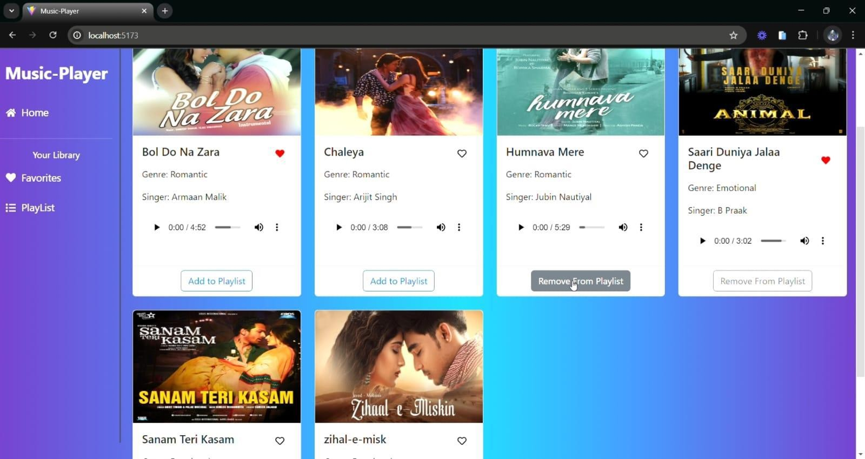Fig 9.1:Screenshot 1*

*Fig 9.2:Screenshot 2*

*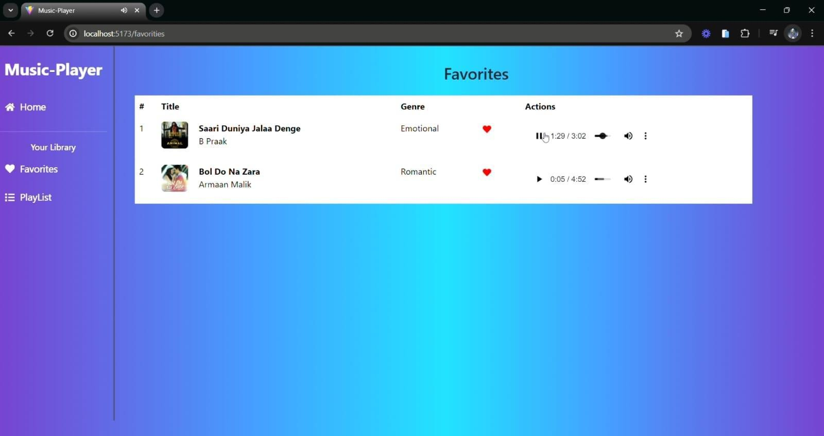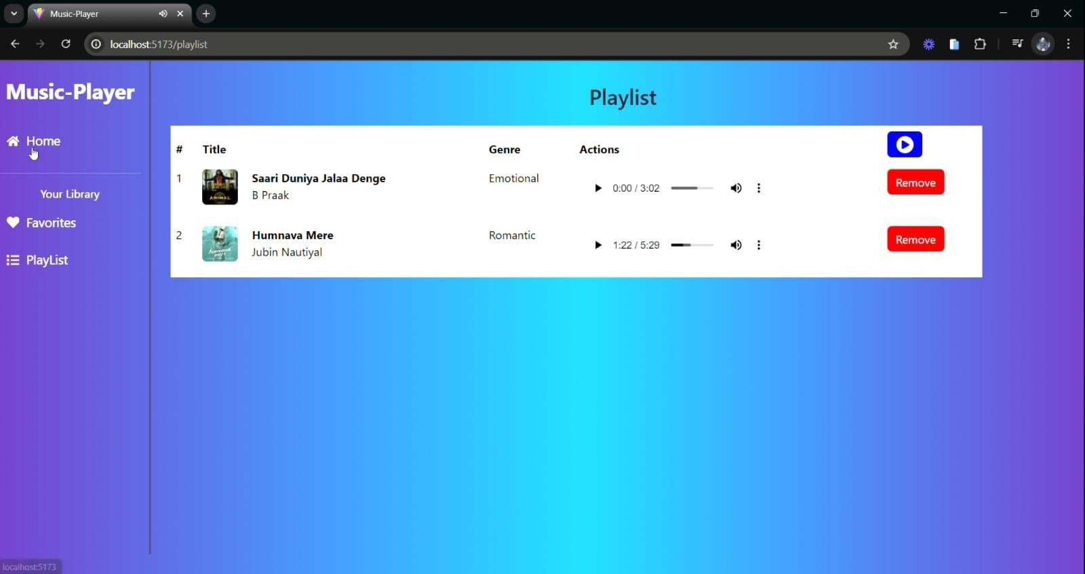Fig 9.3:Screenshot 3*

*Fig 9.4:Screenshot 4*

# STYLING

## Css Framework/Libraries:

CSS Frameworks, Libraries, and Pre-Processors Used in the Music Player Project

The Music Player project utilizes various styling tools to enhance the UI, maintain consistency, and simplify styling.

1. **CSS Framework: Tailwind CSS (or Bootstrap, if used)** Provides pre-designed utility classes for faster styling. Example usage:

<button className="bg-blue-500 text-white px-4 py-2 rounded">Play</button>

### CSS Pre-Processor: Sass (if used)

Enables nesting and variables for more maintainable styles. Example usage (styles.scss)

$primary-color: #3498db;

.button {

background: $primary-color; &:hover {

background: darken($primary-color, 10%);

}

}

### Styled Components (if used in React)

Allows writing CSS directly in JavaScript for component-based styling. Example usage:

import styled from "styled-components"; const Button = styled.button` background: #3498db;

color: white; padding: 10px 20px; border-radius: 5px;

### Custom CSS (styles.css)

Used for global styles and component-specific styles. Example:

.player-container { display: flex;

align-items: center; justify-content: center;

}

These tools improve the design consistency and efficiency of the project’s styling. Let me know if you need more details!

## Theming:

The Music Player project implements theming to allow users to switch between different visual styles, such as light mode and dark mode. This improves user experience and accessibility.

### Theme Implementation Approach

The project may use one of the following methods: CSS Variables (:root)

Allows dynamic theme switching by changing global styles.

:root {

--primary-color: #3498db;

--background-color: #ffffff;

}

[data-theme="dark"] {

--primary-color: #1db954;

--background-color: #121212;

}

Applied in components: document.documentElement.setAttribute("data-theme", "dark"); Styled Components (if used)

Enables dynamic theming inside React components. const ThemeButton = styled.button`

background: ${({ theme }) => theme.primary};

### Theme Toggle Functionality

A toggle button allows users to switch themes dynamically. Example in React: const [theme, setTheme] = useState("light");

const toggleTheme = () => setTheme(theme === "light" ? "dark" : "light");

### Custom Design System

The project follows a structured design system with:

**Typography:** Standardized font sizes and weights.

**Color Palette**: Defined primary, secondary, and background colors.

**Spacing & Components**: Reusable styles for buttons, cards, and modals.

This approach ensures a consistent UI and easy customization. Let me know if you need more details!

# TESTING

## Testing Strategy:

The Music Player project follows a structured testing approach to ensure reliability and performance. It includes unit testing, integration testing, and end-to-end (E2E) testing using popular testing frameworks.

1. **Unit Testing (Jest + React Testing Library)** Focuses on testing individual components in isolation. Tools Used: Jest & React Testing Library.

Example: Testing the PlayButton component:

import { render, screen, fireEvent } from "@testing-library/react"; import PlayButton from "../components/PlayButton"; test("toggles play/pause when clicked", () => {

const togglePlay = jest.fn();

render(<PlayButton isPlaying={false} onClick={togglePlay} />); fireEvent.click(screen.getByRole("button")); expect(togglePlay).toHaveBeenCalled();

});

---

### Integration Testing

Tests how components work together, such as PlayerControls interacting with AudioPlayer. Example: Ensuring volume control updates the audio state:

test("updates volume on change", () => {

const { getByTestId } = render(<VolumeControl />); fireEvent.change(getByTestId("volume-slider"), { target: { value: 50 } }); expect(getByTestId("volume-slider").value).toBe("50");

});

---

### End-to-End (E2E) Testing (Cypress or Playwright)

Simulates user interactions like playing a song or navigating the playlist. Example: Checking if a song starts playing when clicked:

describe("Music Player E2E Test", () => { it("should play a song when clicked", () => { cy.visit("/");

cy.get(".song-item").first().click();

cy.get(".play-button").click();

cy.get(".pause-button").should("be.visible");

});

});

---

Testing Coverage & Automation

Code Coverage: Jest generates reports to track tested components.

CI/CD Integration: GitHub Actions or Travis CI can automate tests on every commit.

This structured approach ensures the app functions correctly across different scenarios. Let me know if you need more details!

## Code Coverage:

Code coverage ensures that tests cover a significant portion of the application's codebase, helping identify untested areas. The Music Player project uses Jest with built-in coverage reporting and additional tools for analysis.

---

### Tools Used for Code Coverage

Jest Coverage Report:

Jest generates a detailed report showing how much of the code is covered by tests. Run coverage analysis with:

npm test coverage

This outputs metrics like:

Statements: Percentage of executed code. Branches: Conditional branches tested.

Functions: Number of tested functions. Lines: Total lines covered.

React Testing Library:

Ensures coverage for UI components and user interactions. Cypress (E2E Coverage, if used):

Measures test coverage for real user flows. Plugin for coverage:

npm install @cypress/code-coverage --save-dev

---

### Ensuring High Test Coverage

100% coverage isn’t required, but aim for 80%+ to ensure reliability. Focus on testing critical functionalities like:

Playback controls (play, pause, skip).

Playlist management (adding/removing songs). Volume & progress bar interactions.

Example: Generating Coverage Report in Jest

{

"jest": { "collectCoverage": true,

"coverageReporters": ["json", "lcov", "text", "clover"]

}

}

This structured approach ensures robust test coverage and minimizes untested code. Let me know if you need more details!

# SCREENSHOTS OR DEMO

*Fig 12.1:Screenshot 1*

*Fig 12.2:Screenshot 2*

*Fig 12.3:Screenshot 3*

*Fig 12.4:Screenshot 4*

# KNOWN ISSUES

### Playback Delay on Some Devices

Issue: Songs may take a few seconds to start playing on certain browsers. Possible Cause: Delay in loading audio files or slow network response.

Workaround: Optimize audio file loading and use preloading technique

### Theme Persistence Not Working Properly

Issue: The dark/light theme setting does not persist after page refresh. Possible Cause: Missing local storage implementation for theme state.

Workaround: Store the theme preference in localStorage and apply it on page load.

### Mobile Responsiveness Issues

Issue: Some UI elements, like the playback controls, may not scale properly on smaller screens.

Possible Cause: CSS media queries not fully optimized. Workaround: Adjust styles for better mobile compatibility.

### Volume Control Not Updating in Real-Time

Issue: The volume slider updates visually but does not immediately affect audio playback. Possible Cause: Delay in syncing state changes with the audio element.

Workaround: Ensure the volume state is applied directly to the audio element.

### Songs Not Looping Properly

Issue: When looping is enabled, some tracks do not restart after finishing. Possible Cause: Incorrect event handling for onEnded in the audio player. Workaround: Ensure onEnded event properly triggers the loop function.

### Lag When Adding Songs to Large Playlists

Issue: Performance slows down when adding a song to a playlist with many tracks. Possible Cause: Inefficient state updates or re-renders

Workaround: Optimize state management and use React's memoization (useMemo, useCallback).

These issues are being tracked for future fixes. If you encounter additional bugs, consider reporting them in the project's GitHub repository.

# FUTURE ENHANCEMENTS

### Offline Mode Support

Allow users to download songs and play them without an internet connection.

### Lyrics Display

Integrate real-time lyrics synchronization for a better user experience.

### Equalizer & Sound Effects

Add a built-in equalizer with presets (Bass Boost, Treble, etc.).

### Smart Playlist Recommendations

Implement AI-based song recommendations based on user listening habits.

### Cross-Platform Syncing

Sync playlists, history, and settings across multiple devices using cloud storage.

### Voice Command Integration

Allow users to control playback using voice commands (e.g., "Play next song").

### Theme Customization

Provide users with options to create and save custom themes.

### Podcast & Radio Integration

Support for streaming podcasts and live radio stations.

### Background Playback & Mini Player

Enable a floating mini-player for multitasking.

### Collaborative Playlists

Allow users to create shared playlists with friends and edit them together.

These enhancements will make the music player more feature-rich and user-friendly. Let me know if you want details on a specific feature!